**Task No. 1:** Write a program that takes a positive integer from the console and prints the square root of this integer. If the input is negative or invalid print "Invalid Number" in the console. In all cases print "Good Bye".

**Solution:**

try

{ char res;

do

{ Console.Write("Enter Number: ");

double num = double.Parse(Console.ReadLine());

if (num < 0)

{

Console.WriteLine("Invalid no");

}

else

{

double square = num * num;

Console.WriteLine("Square of {0} is {1}", num, square);

}

Console.Write("Do you want to check again: ");

res = char.Parse(Console.ReadLine());

} while (res=='y'||res=='Y');

}

catch (Exception error)

{

Console.WriteLine("Good byee!! ");

}

**Output:**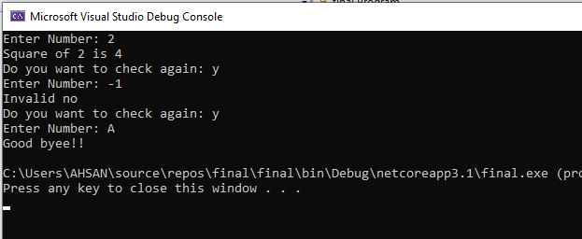

**Task No. 2:** Write a method ReadNumber(int start, int end) that reads an integer array of 10 values from the console in the range [start…end]. In case the input integer is not valid, or it is not in the required range throw appropriate exception.

**Solution:**

try{ Console.WriteLine("input number b/w {0} and {1}", start, End);

int[] num = new int[10];

for (int i = 0; i < num.Length; i++)

{

Console.Write("Enter your Number {0} :", i + 1);

num[i] = int.Parse(Console.ReadLine());

if (num[i] > End || num[i] < start)

{

Console.WriteLine("Invalid !!");

break;

}

}

}

catch (Exception invad)

{ Console.WriteLine("Invalid !!"); }

} static void Main(string[] args)

{

ReadNumber(1, 10);}

**Output:**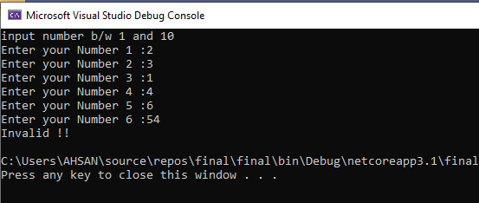

**Task No. 3:** Write a method that takes as a parameter the name of a text file then, reads the file and returns its content as string. What should the method do if an exception is thrown?

**Solution:**

public static void DIsplay(string path)

{ try {

using (FileStream fs = new FileStream(path, FileMode.Open, FileAccess.Read))

{ using (StreamReader reader = new StreamReader(fs, Encoding.UTF8))

{ string content = reader.ReadToEnd();

Console.WriteLine(content); } } }

catch (Exception error)

{ Console.WriteLine("File Not here"); } }

public static void create(string path)

{ using (FileStream fs = new FileStream(path, FileMode.OpenOrCreate, FileAccess.Write))

{

using (StreamWriter writer = new StreamWriter(fs, Encoding.UTF8))

{ writer.WriteLine("this is my last lab task"); } } }

static void Main(string[] args)

{

string path = @"mytaskfile.txt";

DIsplay(path);

create(path);

}

**Output:**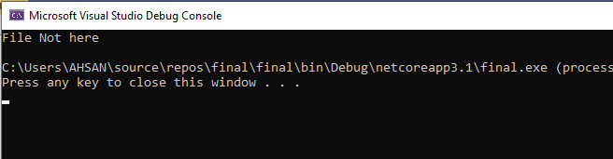

After creating file:

